Task lifecycle

* Active
  + Ready to run
  + Dependency statuses are met
  + ~queued
* Running
  + Node is actively processing the task
* Completed
  + Succeeded
  + Failed

Run multiple tasks on a single node

* Eg. VM (node) has 4 cores: parallel, 4 tasks per core 🡪 a core can run more than 1 task:
* MAX TASKS PER NODE = 4\* core count of node
  + Eg. 4 core VM, 4\*4 = 16
* Scheduling tasks
  + Spreading: distribute across nodes
  + Packing: minimize node utilization
  + 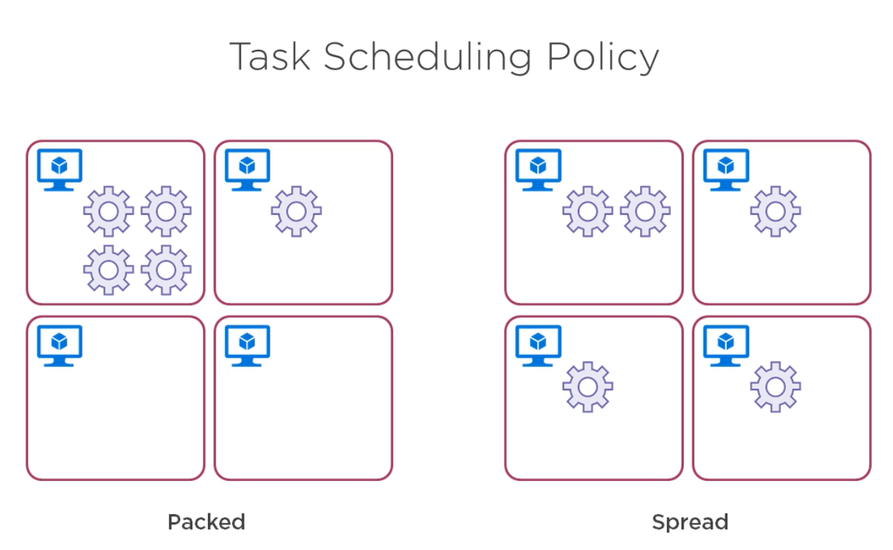
  + 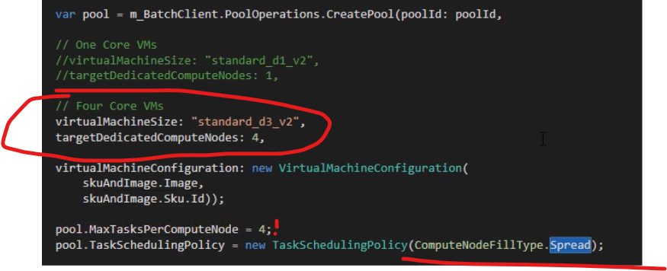

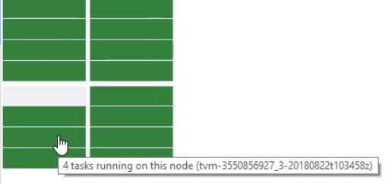

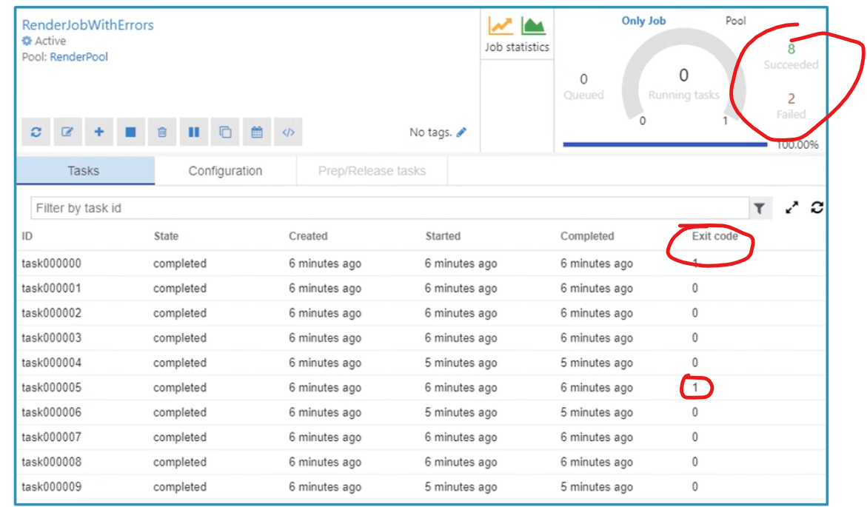

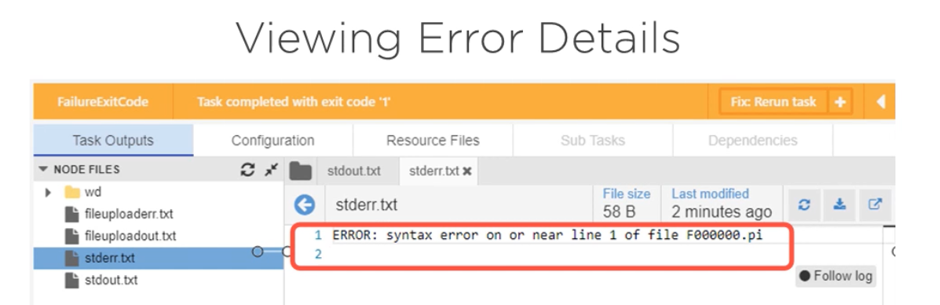

Or in code:

